**School district analysis**

Overview of analysis

This project will help us to understand overall status of different schools in a district. This project will also deliver a high-level snapshot of the district's key metrics and an overview of the key metrics for each school. Tables will be representing different matrices such as performance based on the budget per student, per school size and type of school. Also, this analysis will determine top and bottom five performing schools.

Results

**\*District summary**

By comparing district summary, we can say that district summary is not affected significantly as there are no extreme value found in the entire district school data to skewed distribution either in left or right. Student count in 9th grade for Thomas high school is only 461. And total number of students is 39170. If we observe the ration of 9th grade Thomas high school with total students we see that 1.18% percent of data is replaced by NaN which is insignificant compare to entire data set.

**\* Figure 1 District summary with out ninth grade student of Thomas High School**



**\*Figure 2 District summary with ninth grade student of Thomas High School**



**\*School summary**

In the school summary district Thomas High School data got slightly affected. With out 9th grade data we can see that all the data remained same.

**\* Figure 3 School summary with out ninth grade student of Thomas High School**



**\*Figure 4 School summary with ninth grade student of Thomas High School**



**\*Replacing the 9th graders’ math and reading scores of Thomas High School**

As we have seen earlier replacing data for only 9th grade of Thomas high school which is only 461 students did not affect data significantly. We can see from figure 3 & 4 that average math score decreased by 0.07 and average reading score increase by 0.05 which is insignificant.

**\*Replacing the ninth-grade scores affect the following:**

**\*Math and reading scores by grade:** Almost math and reading scores remains same for all the school. As we have replaced the grades for both reading and math of Thomas high school by NaN, there is no scores fort ninth grade.

**\*Scores by school spending:** No affect found in scores by school spending. Both summary values remain same.

**\* Figure 5 Spending summary with out ninth grade student of Thomas High School**

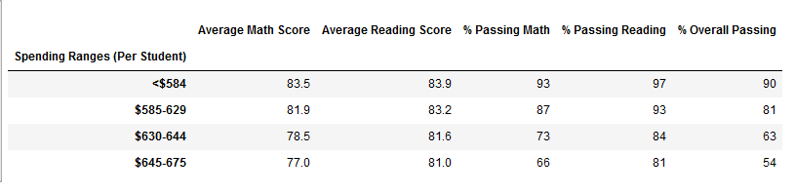

**\*Figure 6 Spending summary with ninth grade student of Thomas High School**

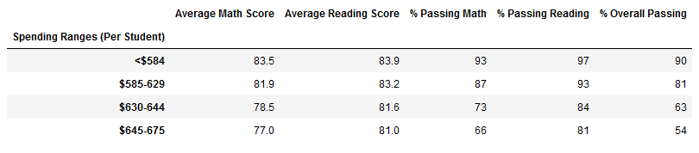

**\*Scores by school size:** No affect found in scores by school spending. Both summary values remain same.

**\* Figure 7 Size summary with out ninth grade student of Thomas High School**

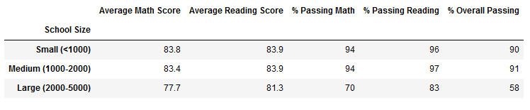

**\*Figure 8 Size summary with ninth grade student of Thomas High School**

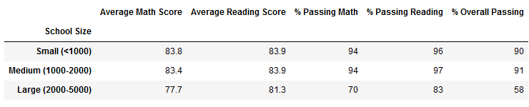

**\*Scores by school type:** No affect found in scores by school spending. Both summary values remain same.

**\* Figure 9 School type summary with out ninth grade student of Thomas High School**

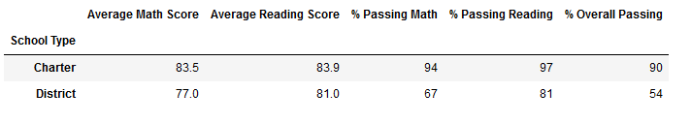

**\*Figure 10 School type summary with ninth grade student of Thomas High School**

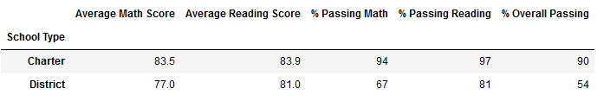

**Summary**

**In the end we can see that there are some slight changes in the below mentioned columns of district school summary after replacing Thomas high school’s 9th grade data.**

*Average match score decreased by 0.1.

*Passing math decreased by 0.2

*Passing reading decreased by 0.3

*Overall passing decreased by 0.1